## PROJECT DEVELOPMENT-DEIVERY OF SPRINT-4

**TEAM ID: PNT2022TMID18845**

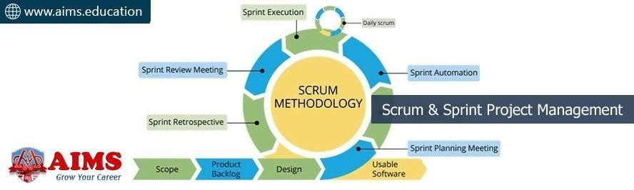

**Tools for Scrum Project:**

1. **JIRA SCRUM:**

With Jira scrum, you will be able to make it easy to track and schedule tasks as well as monitor progress.

1. **TRELLO:**

With Trello, you can easily create a board to add all the smaller, broken-down tasks. This means that you can definitely use Scrum from Trello for your projects.

Between creating a list each for “To Do,” “Doing,” and “Done”, you can add as many columns as you want or need. And when you have a lot of items to review, add a special column.

### REDMINE SCRUM:

This easy-to-set-up plugin allows you to configure all your projects quickly. Between product backlog, adding task boards with drag and drop, and checking Sprint burndown charts and stats, you’ll be able to manage your projects better.

# ASANA SCRUM:

With Asana Scrum, you will be able to plan, organize, and manage agile projects in a tool that’s as flexible and collaborative as your team.

You will be able you easily track launches, give feedback and iterate, keep track of sprint planning and milestones, and even improve communication between team members.

# PMI SCRUM:

With PMI Scrum, you will allow teams to respond rapidly and efficiently to any required changes in the process.

### PRINCE2 SCRUM:

. With Prince2 Scrum, you can better manage and control your projects. Besides, it also provides good guidance to the key stakeholders on how to ensure the project is managed effectively

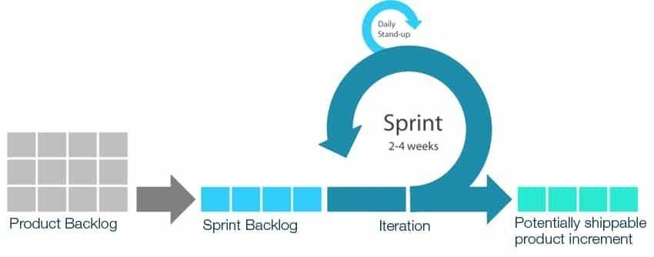

# Sprint Project Management:

When talking about project management, it is almost impossible not to refer to sprints. Sprint project management is a process that consists of the

activities involved in planning, executing, and managing a project.

* + Simply put, sprints are a period of time to complete and review a certain task or activity.
  + It begins with a meeting where the customer and the project team discuss the work that needs to be completed.
  + At this point, the project team will need to determine how much time they need to complete the work while the customer needs to point out the type of work that needs to be completed.

# Best practices for running a sprint planning meeting

1. Start with the big picture. ...
2. Present new updates, feedback, and issue. ...
3. Confirm team velocity and capacity. ...
4. Go over backlog items. ...
5. Determine task ownership. ...
6. Confirm new issues, impacts, and dependencies. ...
7. Reach a group consensus. ...
8. Officially begin your sprint.

## EXAMBLE:

Sprint planning is **an event in scrum that kicks off the sprint**. The purpose of sprint planning is to define what can be delivered in the sprint and how that work will be achieved. Sprint planning is done in collaboration with the whole scrum team.

**Sprint Planning Meeting: Tools and Templates**

Sprints are fundamental to the Agile [product](https://www.nuclino.com/articles/product-management) [management](https://www.nuclino.com/articles/product-management) workflow. A **sprint** is a short, time-boxed period (usually a month or a week), during which a set amount of work has to be completed. It's a popular technique used in the Scrum and Agile methodologies to break up arger projects into more manageable pieces.

A successful sprint planning meeting will yield two important items:

* + **The sprint goal**: A summary of what you plan to accomplish during the sprint.
  + **The sprint backlog**: A list of user stories and backlog items the team has agreed to work on in the upcoming sprint.

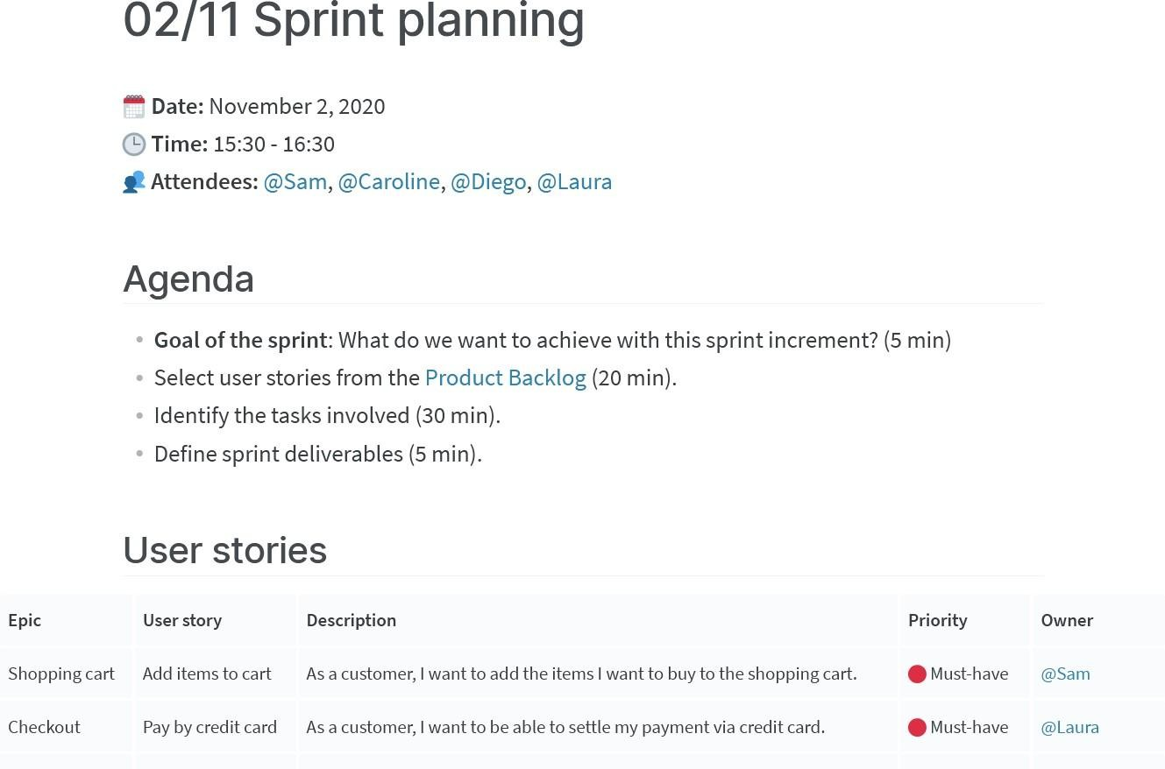

### Sprint planning tools

There are dozens of sprint planning tools you can choose from. Some of them are fairly basic, while others are packed with complex features and customization options. There is no one-size-fits-all, and depending on your team's unique workflow and requirements, a different solution may be a better fit.